Erica Miller

11/22/24

NURS 5023

Community Education Project Reflection

For this assignment, I worked with Chelsea Hammond, and we decided to teach a Kindergarten class about the importance of handwashing. With the winter months coming up and the peak of cold and flu season, it’s a great time to remind young kids just how important it is to wash their hands. Kids, particularly young ones, are vulnerable to infections because of poor hand hygiene and constant exposure to germs at school. I am currently doing clinicals at Fast Pace Urgent Care, and I see how quickly an illness can spread and how hard it can hit infants, and children.

I got permission from the principal and teacher at Town Acres Elementary School in Johnson City, Tennessee to present our lesson to Mrs. Miller’s Kindergarten Class. For the project, we created a PowerPoint that Chelsea will be submitting that explains how germs can make us sick and why handwashing is so important. We also took turns reading a children's book titled “Germs vs. Soap” which helps explain how soap works to wash away germs to their level of understanding.

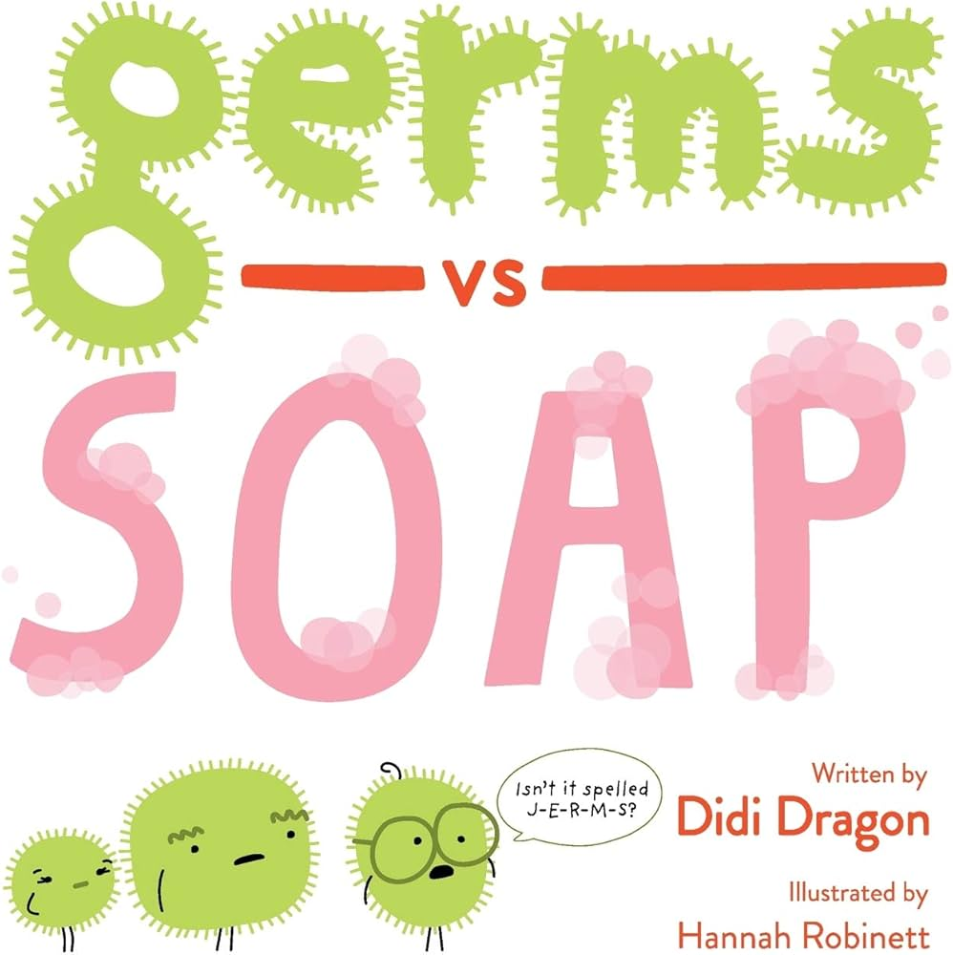

We also did a handwashing activity with each student to make the lesson more interactive. I purchased a germ powder kit from Amazon to reveal “germs” on each child’s hands. Chelsea used the blacklight to show them where the germs were before and after they washed their hands. The kids seemed very shocked to see how thorough they truly needed to be with their hand-washing skills. We also gave each child a "Wash Your Hands" coloring sheet to take home as a reminder of what they learned during our visit.

The kids stayed engaged throughout the presentation and enjoyed the activities. Teaching them this important skill was very fun and rewarding. One thing we learned during our time with this class is how hard it is for kids to get rid of all the germs on their hands. Very few were able to wash them off completely on the first try! Thank you so much for including this assignment in our course. We had a blast!